DATE: 2025-11-30
REVISON: A

TO: Geoffrey Butler, AE460 Instructor

FROM:
Aleborn
Ethan Barichievich
Maxwell O’Neill MO

SUBJECT: Wing and Stabilizer Layout for AIAA Carrier-Based Strike Fighter

OBJECTIVE
Using the tail volume results from TM-5 as the baseline for TM-6, a planform and side view CAD layout of the main wing, horizontal, and vertical stabilizers were constructed in SolidWorks. The memo provides the geometric parameters required for the drawing, which includes and coordinate system, planform areas, aspect ratios, taper ratios, sweep angles, mean aerodynamic chord, as well as relative fuselage location with relation to the wing and tail surfaces. A top view and side view were modeled as part of the conceptual phase.

SUMMARY
The final conceptual layout displays a 41.5 ft-span with a tapered main wing positioned approximately 250 (in) after FS0 for the leading-edge MAC. Previously, the horizontal stabilizer area was calculated to be 90 $({ft}^{2}$) which is located 18.08 (ft) aft of the wing quarter chord. This also gives a horizontal tail volume coefficient of 0.1634. The conceptual design has twin fin arrangements for the vertical stabilizers with a total aera of 101.77 ${(ft}^{2})$ which is located 17.88 $({ft}^{2})$ aft of the wing’s quarter chord. Using these parameters the vertical tail coefficient was determined to be 0.0803. All sizing parameters trace to TM-2, TM-3, and TM-5. This geometry specified in this memo will be used for TM-7 Takeoff, Landing, and Balanced Field Length as well as TM-8 Layout and Mass Properties.

SUPPORTING DOCUMENTATION

Table 1: Wing Geometry
Parameter | Units | Value
Planform area | $S_{h}$ (${ft}^{2}$) | 600
Span | B (ft) | 41.5
Aspect Ratio | AR | 2.87
Taper ratio | $$λ$$ | 0.2
Sweep (LE ¼ c, ½ c, TE) | Deg | 43
Root Chord | in | 289.157
Tip Chord | in | 45.337
MAC Length | in | 199.196
Wing LE MAC from FSO | in | 340.299

Table 2: Horizontal Stabilizer Geometry
Parameter | Units | Value
Planform area | $S_{h}$ (${ft}^{2}$) | 90
Span | B (ft) | 19
Aspect Ratio | AR | 4.0
Taper ratio | $$λ$$ | 0.40
Tail Volume Coefficient | $$V_{h}$$ | 0.1634
Moment Arm (Wing 1/4c -tail1.4c) | $$I_{h}$$ | 18.08
Sweep (1/4 c line) | deg | 29

Table 3: Vertical Stabilizer Geometry
Parameter | Units | Value
Planform area | $S_{h}$ (${ft}^{2}$) | 101.77
No. of Fins | -- | 2
Area Per Fin | $${ft}^{2}$$ | 50.88
Span | B (ft) | 6
Aspect Ratio | AR | 2.823
Taper ratio | $$λ$$ | 0.2
Tail Volume Coefficient | $$V_{h}$$ | 0.08025
Moment Arm (Wing 1/4c -tail1.4c) | $$I_{h}$$ | 17.875
Sweep (1/4 c line) | deg | 35

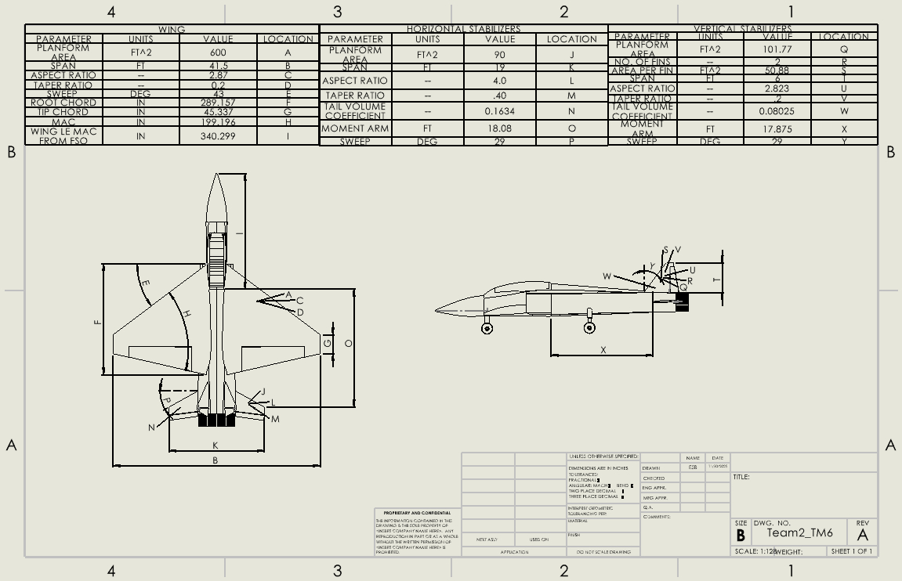
Figure 1: Layout

REFERENCES

[1.] Roskam, J., Airplane Design, Part II: Preliminary Configuration Design and Integration of the Propulsion System, DARcorporation, 1985.

[2.] Pamadi, B. N., Performance, Stability, Dynamics, and Control of Airplanes, 3rd ed., AIAA Education Series, 2017.

[3.] Team 2 (Aleborn), TM-2 Preliminary Weight Estimates, SDSU AE 460A, 2025-09-28.

[4.] Team 2 (Aleborn), TM-3 Wing Sizing, SDSU AE 460A, 2025-10-05.

[5.] Team 2 (Aleborn), TM-5 Empennage Sizing, SDSU AE 460A, 2025-10-19.

[6.] AIAA, 2025–2026 Undergraduate Aircraft Design Competition RFP: Next-Generation Carrier-Based Strike Fighter, AIAA, 2025.

